- The tighter-than-expected vote and more dovish tone from the Monetary Policy Committee reinforce our conviction that rates will be cut again by the April meeting. The MPC could move in March if the data surprises to the downside or financial markets clearly price a cut.
- The MPC's dovish shift was in response to downgrading its growth forecast, which it brought into line with our projection. It expects this to generate more slack, justifying looser policy this year. The committee has also become less concerned about the strength of pay growth, having suggested this was a key worry in December.
- A divided committee, inconsistent messaging from one meeting to another, and today's switch to favour the central forecast over the data flow and scenarios make it hard to be certain where Bank Rate will go this year. We think two 25bp cuts is the most likely outcome.
The Bank of England's Monetary Policy Committee voted 5-4 to hold Bank Rate at 3.75% at today's meeting. The four dissenters – Sarah Breeden, Swati Dhingra, Dave Ramsden, and Alan Taylor – preferred a 25bp cut.
The tight margin was a big surprise; we expected only two votes for a cut. In December, Breeden and Ramsden voted to cut but struck a cautious tone on the scope for further loosening, with the strength of forward-looking pay indicators their main concern. So their switch to vote for back-to-back cuts was unexpected. The minutes made it clear that this change of heart was not triggered by data developments. Rather, they were influenced by BoE staff analysis presented in the Monetary Policy Report.
On the labour market, the BoE's analysis suggested wage growth was on track to fall to a target-consistent pace this year, and that it's less likely there have been structural changes in the labour market that could keep pay growth elevated. On activity, the BoE has become more cautious on the near-term outlook, cutting its 2026 forecast for GDP growth to 0.9%, in line with our projection and 0.3ppts below its November forecast (Chart 1). Coming on top of further loosening in labour market conditions, the weaker growth outlook led the MPC to conclude that there would be more slack in the economy.
Chart 1: The BoE's downgrade brought its forecast into line with our projection
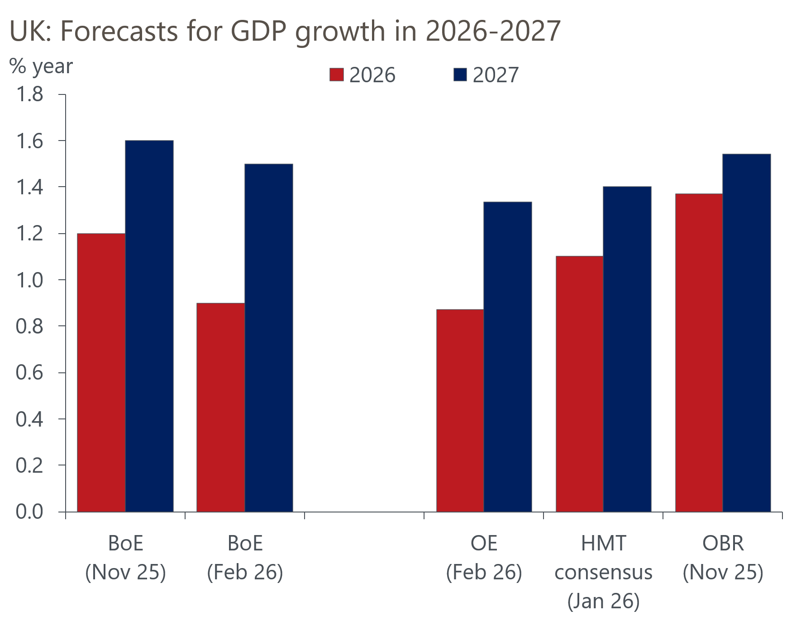
Sources: Oxford Economics, BoE, HMT, OBR

The MPC's decision to lower its growth forecast was made despite the new projections incorporating the near-term loosening of fiscal policy announced in November's Budget. Though the new inflation projections were much lower, reflecting recent data and the Budget announcements that some energy levies would be removed and rail fares would be frozen, the BoE opted not to revise its expectations up for consumer spending. While it did pencil in higher government spending, the impact was more than offset by lower housing investment.
The new forecast looks reasonable. But given the nature of the revisions, we found it surprising that the forecast was such a big influence on the MPC's thinking. Indeed, the emphasis shift towards the forecast and away from the data flow signals a major change in the MPC's thinking compared with recent years. It's also notable that the importance of the BoE's scenarios was downgraded in today's communications – scenarios had played a key role in explaining voting patterns in November, but they were barely mentioned in February's minutes and had a muted role in the MPR.

Next cut to come in March or April
We take today's messaging as confirmation that the MPC is likely to cut again at one of the next two meetings, but the timing of its next move has become less clear. Previously, we favoured the end-April meeting for the next cut, on the basis this would give the MPC more time to consider the incoming pay data, the issue it cited as being a key consideration. But today's communications suggest the pay data is no longer quite as important. Given the committee's concerns about activity, there could be greater focus on the two monthly GDP releases that will be published before the March meeting, although long-running issues around residual seasonality could complicate the analysis of this data.
The other wild card is Catherine Mann. With one notable exception last February, Mann has always been one of the most hawkish members. But her paragraph suggested "the appropriate time for a cut in Bank Rate [was moving] closer." In four of the past five meetings, Governor Andrew Bailey has cast the decisive vote. But the possibility of Mann completing her volte-face offers a second possible path to securing a majority for a rate cut.
So, we regard the March meeting as being little more than a coin toss. If the data surprises to the downside or financial markets decisively price a cut ahead of the meeting, that would probably be enough to tip the balance in favour of a March cut.

We maintain our call of two 25bp cuts in 2026
The direction of policy further out remains difficult to call. The MPC remains deeply divided, and it's unlikely we'll see the run of close votes ending soon. Its messaging remains inconsistent from one meeting to another. We had hoped that the introduction of individual paragraphs in the minutes would make it easier to track the views of each member, but the sudden changes of view by Breeden and Ramsden between December and February, and the more general switch from hawkish to dovish messaging, leave us less certain about what each member is looking for. Extra confusion has been caused by the move from data-dependence to a more forward-looking approach that leans on the BoE's forecasts, and by the inconsistent use of scenarios.
We think the most likely outcome is that the MPC cuts twice in 2026, in March or April and November. This would leave Bank Rate at 3.25% at the end of the year. In response to a question at the press conference, Bailey suggested that market pricing implying a similar level at the end of the year was "reasonable".

